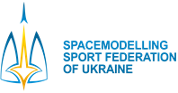
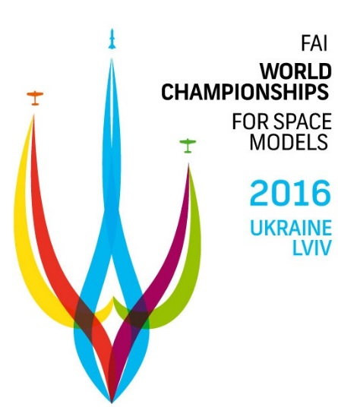

2016 FAI S WORLD CHAMPIONSHIPS FOR SPACE MODELS
FOR SENIORS AND JUNIORS
22-30 AUGUST 2016, LVIV, UKRAINE

PRELIMINARY ENTRY FORM

NATIONAL AEROCLUB/FEDERATION OF ____________________________________________
CORRESPONDANCE ADDRESS ____________________________________________
__________________________________________________________________________________
FAX ________________________________
PHONE ________________________________
e-mail ________________________________

NATIONAL TEAM:
Contact person __________________________

- Team Manager for seniors _________________
- Team Manager for juniors _________________
- Team manager assistants _________________
- No. of seniors competitors _________________
- No. of juniors competitors _________________
- 2014 World champions seniors _________________
- 2014 World champions junior _________________
(in accordance with SC4 Vol ABR par.B.3.4 (e))
- Timekeeper (maxim 2/team) _________________
- Helpers _________________
- Supporters _________________
- Press representatives _________________
- No. of persons in hotel _________________
TOTAL PERSONS ___

Please fill in (with capitals) and return to e-mail of Spacemodelling Sport Federation of Ukraine:

E-mail: info@frms.ua
web www.frms.ua
TEL: +38 063 239 02 21
Contact person: Julia Trigub

PLEASE RETURN BY 25TH OF FEBRUARY 2016.

DATE___________ SIGNATURE & STAMP OF Nac/FEDERATION

